GescaCFS website

Tabla de contenido

Information about documentation 3

Main Page 4

Introduction 4

Login and register 5

Register 5

Login 7

File Manager 9

Introduction 9

Delete Templates 9

Delete Documents 10

Account Manager 11

Introduction 11

Delete Account 11

Navigation Bar 12

Introduction 12

Logout 13

Create Page 14

Introduction 14

Creating Document Template 14

Creating Document template step by step (pictorially explained) 15

Field types 16

Text 16

Date 16

Checkbox 16

Fill page 17

Introduction 17

How to fill a document? 18

See page 19

Introduction 19

How to preview a document? 20

How to download a document? 20

How to delete a document? 20

Document naming rules 21

# Information about documentation

**That documentation is only valid to english version of website.**

Version of website that documentation is valid for 2.0

Github link for that version:

<https://github.com/Anty150/GescaCFS/tree/2ddff4ae3b7e7efc6f95a89482076d9b61df6f10>

**This documentation may or may not be valid for newer versions of that website.**

In current version of documentation usage of admin panel is not covered.

# Main Page

## Introduction

First thing you will see after opening the website is the Main Page. On the left (or in the upper área, if using mobile), you can see Navigation Bar (from now on tutorial will refer to it as navBar), we will return to it later. Another thing you will notice are two big buttons “login” and “register”, used to creating and logging to your account.

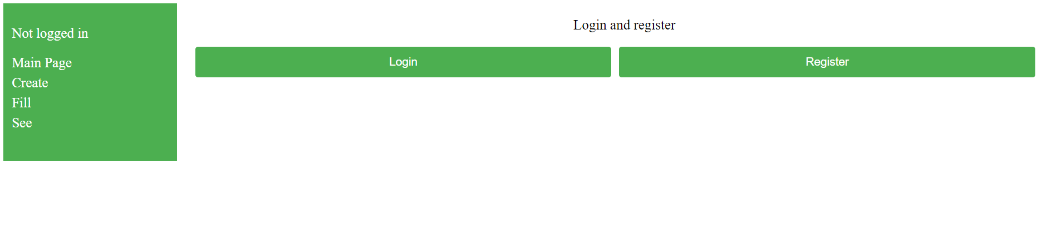

Ilustración 1 Main Page (Desktop)

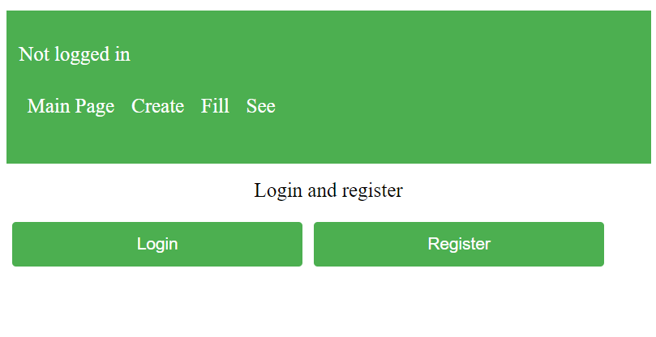

Ilustración 2 Main Page (Mobile)

## Login and register

If it is your first visit to website it is recommended to use register button to create new account (account is needed to use the website). You can also login if you have an account.

### Register

1. Click Register button

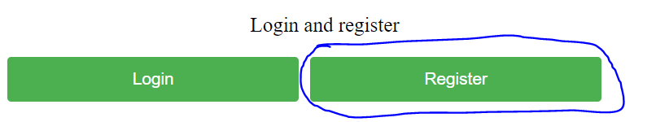

Ilustración 3 Register button

1. After that a new view will appear. Here you can see two input fields and two buttons.

The first input is used to enter desired username (it has to be unique (there can not be two users with the same username)), the second one is used to input password, your paswword must be at least 8 characters long, otherwise your account won’t be created and error will be logged on Main Page (you will be returned there right after unsuccesful account creation attempt). Now let’s explore the buttons. Register button is used to finish registering process, and login button is used to redirect user to login page without returning him to the Main Page, in case he clicked the wrong button.

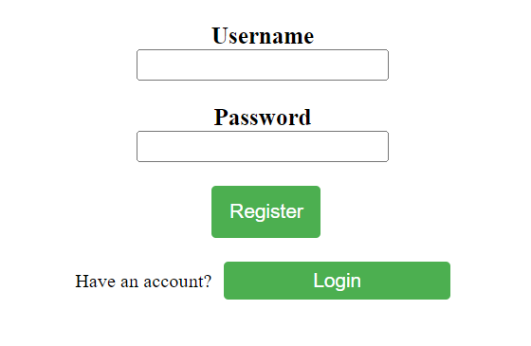

Ilustración 4 Register page

1. Now you can input your desired username (remember it has to be unique) to username field, after doing so input desired password (it has to be at least 8 characters long).

**WARNING! As it is an early version of the website it is not posible to recover your password, so write it down somewhere!**

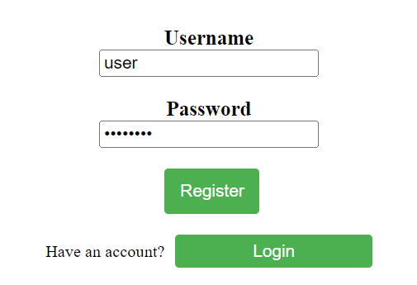

Ilustración 5 Example data

1. After inputing data, press Register button.
2. If you did everything properly and your username was not taken, your account is now created and you can login. As you noticed, you were redirected to the Main Page, where you can Login or Register again.

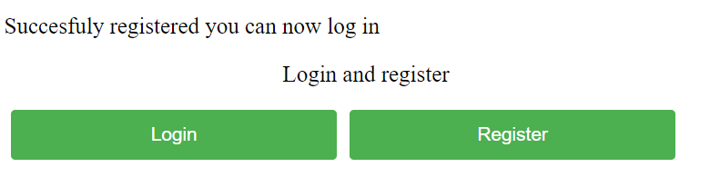

Ilustración 6 Succesful Register

### Login

1. Click Login button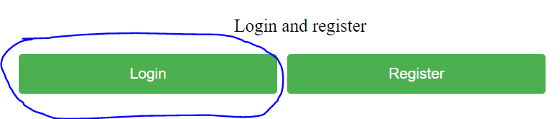

Ilustración 7 Login button

1. After that a new view will appear. Here you can see two input fields and two buttons.

The first input is used to enter your username, the second one is used to enter password you entered during registration. If login attempt is unsuccesful you will be redirected to the Main Page, with proper error logged. Now let’s explore the buttons. Login button is used to finish logging process, and Register button is used to redirect user to Register page without returning him to the Main Page, in case he clicked the wrong button.

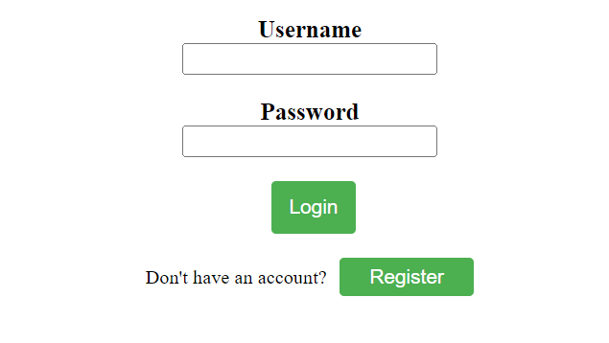

Ilustración 8 Login page

1. Now enter your username to username field, then enter your password to password field.
2. After doing so, click Login button.
3. If your account exists and you entered valid data, you will be redirected to Main Page and new options will appear. Also notice that in the upper left corner (Or in the uppper area of navBar, if using mobile view) your username is displayed.

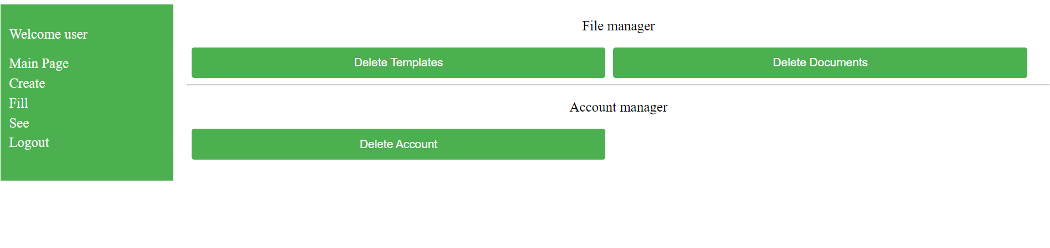

Ilustración 9 Succesful Login (Desktop)

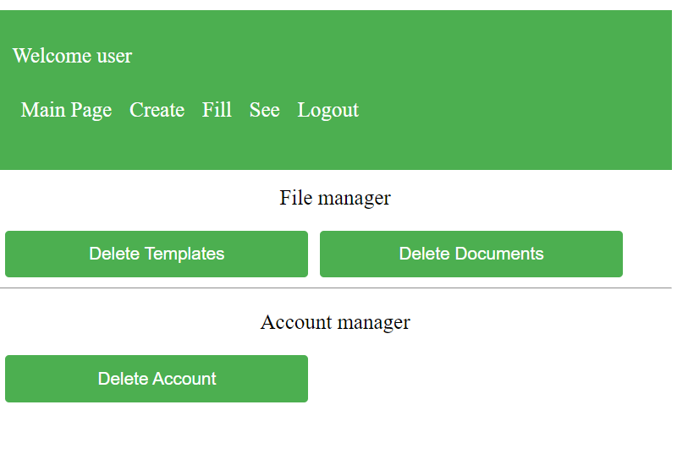

Ilustración 10 Succesful Login (Mobile)

## File Manager

### Introduction

File Manager is used to manage your created documents and document templates, it consits of two buttons:

* Delete Templates
* Delete Documents

Both will redirect you to their proper pages.

### Delete Templates

Delete Templates is used to delete templates you created in Create page. After being redirected here from Main Page, you will notice a Text Box and two buttons. Text Box may or may not be empty (depending if you have created any document templates). Below him is Delete button, used to delete currently selected template (to do so click unwanted template name in the Text Box) and Remove All button, used to delete all created templates.

**WARNING! There is no way to get deleted templates back!**

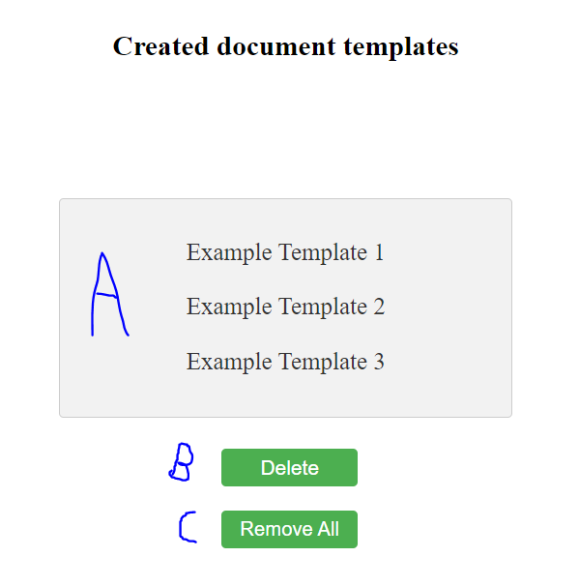

Ilustración 11 Delete Templates (A - Text Box, B - Delete button, C - Remove All button)

### Delete Documents

Delete Documents is used to delete documents you created in Fill page. After being redirected here from Main Page, you will notice a Text Box and two buttons. Text Box may or may not be empty (depending if you have created any document). Below him is Delete button, used to delete currently selected document (to do so click unwanted document name in the Text Box) and Remove All button, used to delete all created templates.

**WARNING! There is no way to get deleted documents back!**

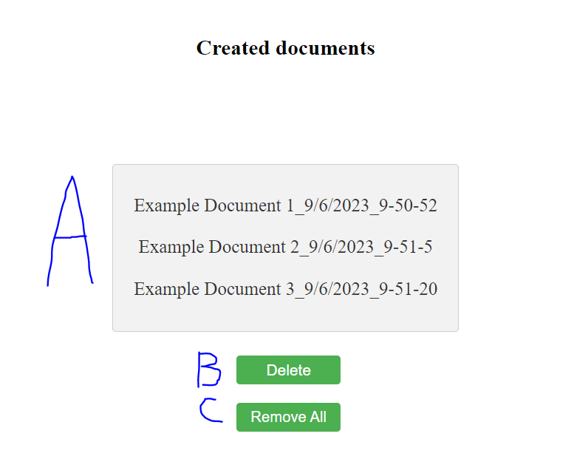

Ilustración 12 Delete Documents (A - Text Box, B - Delete button, C - Remove All button)

## Account Manager

### Introduction

Account manager is used to manage your account, here you can see Delete Account button, responsible for deleteting your account.



Ilustración 13 Account Manager

### Delete Account

**Delete Account is used to delete your account if you need to do so. To do it succesfuly, click Delete Account button, then confirm alert that appeard after that. If done correctly your account should be deleted and you should be redirected to the login page.**

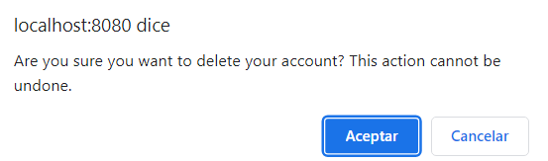

Ilustración 14 Delete Account Alert

# Navigation Bar

### Introduction

Navigation Bar (also refered as navBar) is primary method of navigating the website. In version 2.0, it has 4 buttons (5 if you are logged in). We will discuss each button in their proper section later. To use navBar, click desired button (for example if you want to create document template click Create button). Another thing worth noticing is that it displays your username after succesful login.

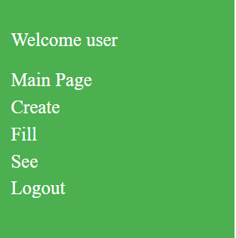

Ilustración 15 Navigation Bar (Desktop)

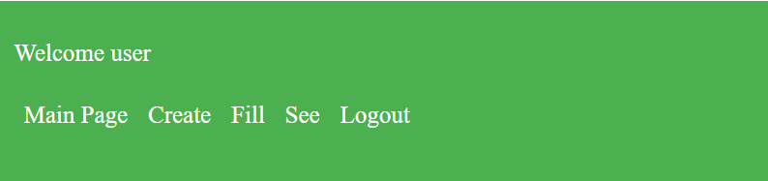

Ilustración 16 Navigation Bar (Mobile)

### Logout

The last element of navBar is Logout button, it is visible only when you are logged in, otherwise it is not there.

Logout button is responsible for logging user out, it used when:

* You want to change account
* You finished using your account

After pressing Logout button you will be logged out, and redirected to Login page.

We highly recommend logging out, because it ensures that every Session variable is safely unset, preventing unwanted data leaks.

# Create Page

## Introduction

Create page is used to create document templates, for further use in FIll page. Here user can define template name, field name and type. Here, user can also preview created template and edit it’s contents, before submitting it

## Creating Document Template

Creating document templete is easy and fast process, to do so please follow these steps:

1. Enter document template name into Name field.
2. Enter wanted field name
3. Select field type
4. Press plus button to insert created field into Text Box.
5. If you want to remove added field from your template, select it by clicking on it in Text Box, then press minus button.
6. If you want to save created template, please click submit button.

**Please note that template name must be unique and you can not create template without name or fields. Same applies for fields – every field must have a name, although it does not have to be unique.**

**WARNING! After submitting template it cannot be edited!**

.

### Creating Document template step by step (pictorially explained)

1. 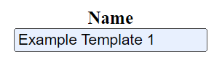

Ilustración 17 Document template field

1. 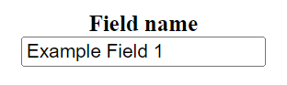

Ilustración 18 Field name field

1. 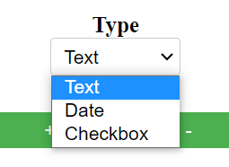

Ilustración 19 Type Combobox

1. 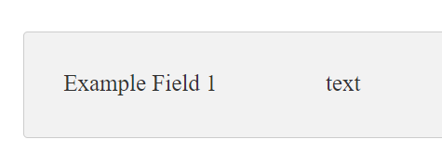

Ilustración 20 Created field in Text Box

## Field types

Each field has a type. It helps user to input correct data to specific fields.

There are three types of field:

* Text
* Date
* Checkbox

Each type is used to create diffrent type of field, as it accepts diffrent inputs.

Because of safety and memory saving reasons, current limit to text field name is 50 characters.

### Text

Text is used when you want to input everything that can be written down using your keyboard.

Example text fields:

* Name field
* Age field
* Product name field
* Document author name
* Serial number field

### Date

Date is used when you want to input specific date using browser supplied calendar.

Example date fields:

* Birth date field
* Event date field

### Checkbox

Checkbox is used when you want to check if statment is true or false. If checkbox is ticked then the statement is true, otherwise it is false.

Example checkbox fields:

* IsDone field
* IsPayed field
* IsCreated field

# Fill page

## Introduction

Fill page is used to create documents from created document templates. User can do it by simply filling input fields after selecting document template.

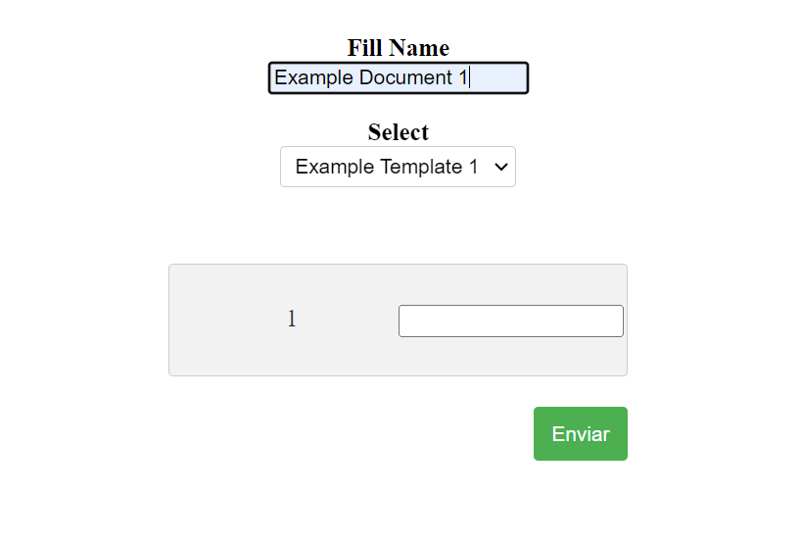

Ilustración 21 Fill Page

## How to fill a document?

Filling created template is simple and very fast process. To do it properly follow these steps:

1. Enter wanted document name in Document field
2. Select document template in Select combobox
3. Start filling created fields
4. After filling all fields, press submit button

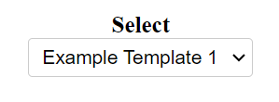

Ilustración 22 Select combobox

# See page

## Introduction

See page is used to preview and download your created documents. Additionally you can also delete selected document from your account.

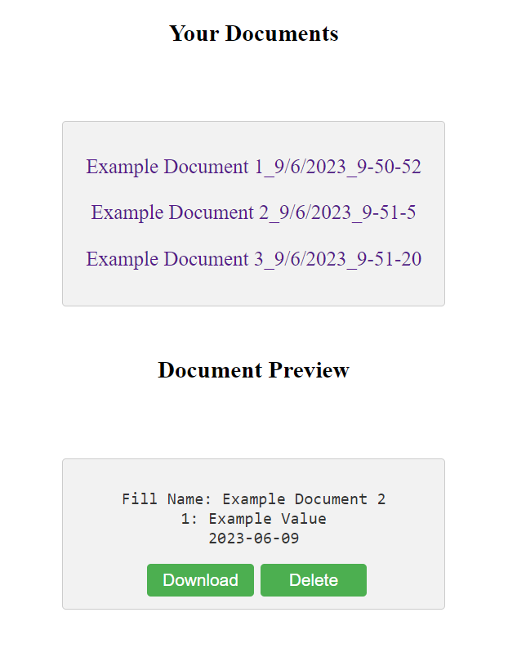

Ilustración 23 See Page

## How to preview a document?

To preview a document follow these steps:

1. Click document name you want to preview (in case your document name is not what you filled in Fill page, refer to Naming rules section).
2. In the lower Text Box clicked document’s contents should appear

## How to download a document?

To download a document follow these steps:

1. Click document name you want to download (in case your document name is not what you filled in Fill page, refer to Naming rules section).
2. In the lower Text Box clicked document’s contents should appear, with two buttons below.
3. Now, press Download button

## How to delete a document?

To delete a document follow these steps:

1. Click document name you want to delete (in case your document name is not what you filled in Fill page, refer to Naming rules section).
2. In the lower Text Box clicked document’s contents should appear, with two buttons below.
3. Now, press Delete button.

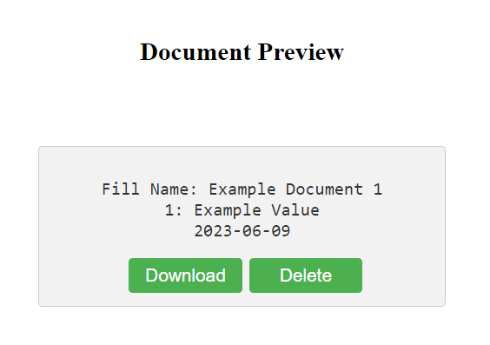

Ilustración 24 Document Preview

## Document naming rules

Every document’s name has to be unique so having user’s comfort in mind automatic naming has been implemented.

There are two rules that apply automatically to every name:

1. If document name is empty then it will be named “Unnamed Document”
2. To make every document name unique date:hour:minute:second of creation is added to every name